MULSANNE INSURANCE COMPANY LIMITED

Monthly submission Solvency report

For the month ended 30 June 2025

1. Summary 1

2. Solvency II Own Funds 2

3. Solvency Capital Requirements (SCR) 3

4. Solvency II Technical Provisions Reconciliation 4

5. Quantitative reporting templates (QRTs) 6

# Summary

* 1. The objective of this document is to highlight the Solvency II results as at ‘30th of June 2025’ for Mulsanne Insurance Company Limited (MICL).
  2. The document contains:
     1. A high-level summary of the current solvency position.
     2. A section with a description of how the Solvency II Own funds have been derived and varied. This contains a reconciliation, a study of variance and a waterfall chart from Statutory Own Funds to Solvency II.
     3. An additional section describing the Solvency Capital Requirements (SCR), drivers and explanations on the movements.
     4. Solvency II technical provisions reconciliation with GAAP.
     5. Main reporting templates to be filed for regulatory purpose.
  3. Key Solvency II results for this quarter end are shown in the table below:



* 1. SCR Coverage, **106.46%**.
  2. Solvency II Own Funds have decreased -£4m whilst GAAP Own Funds have decreased -£3.5m driven by various adjustments that will be further explained in section 2.
  3. Solvency capital requirements have increased (+£102k) driven mostly by underwriting reserve risk, however, other modules have also contributed to the final movement. This will be further explained in section 3.

# Solvency II Own Funds

* 1. The table below highlights the monthly change in both Statutory and Solvency II own funds and helps identify the main drivers of variance:



* 1. Movement in SII Own Funds is £558k more negative than the one in GAAP Own Funds driven by the following main factors:



* 1. The graph below shows the Solvency II Own Funds walk from Statutory accounts as at 30th of June 2025:

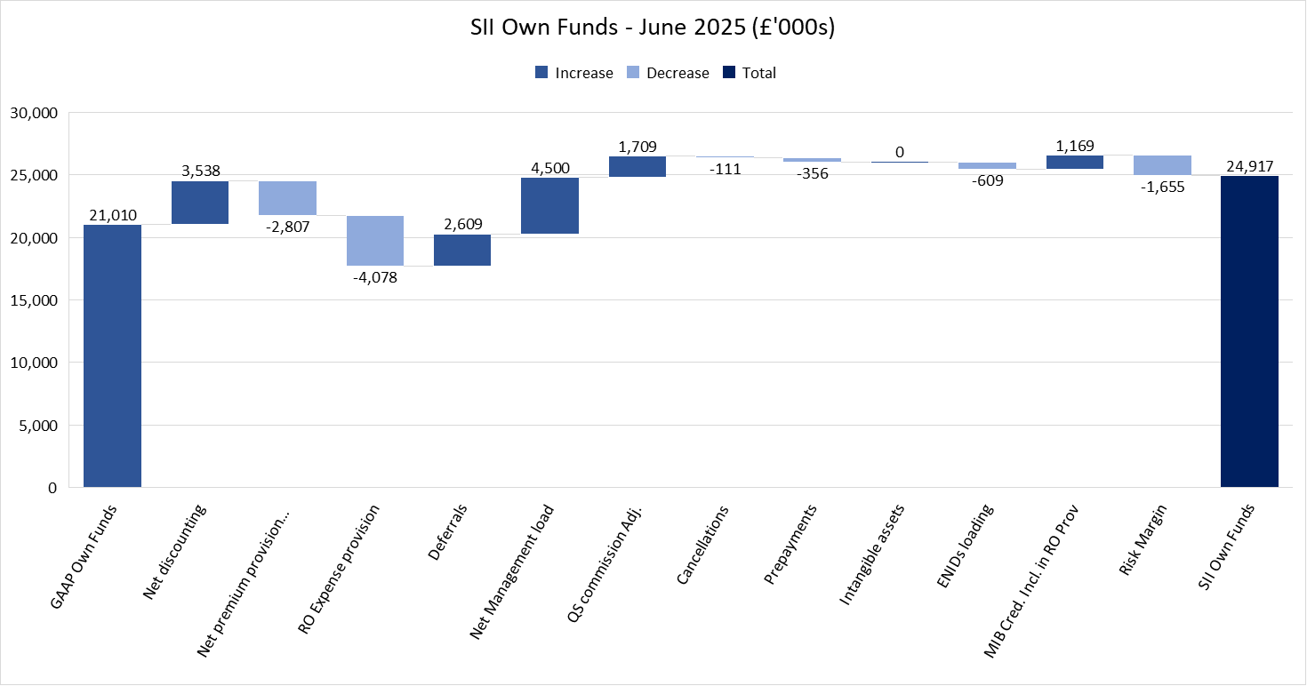

# Solvency Capital Requirements (SCR)

1. 1. Solvency capital requirements are £23.4m as of June-25 which is +£102k increase compared to the figure reported in the May submission.
   2. The table below highlights the monthly SCR movement by risk module:



* 1. The increase in total SCR (+£102k) is primarily driven by Underwriting risk (+£164k), specifically by Reserve risk which has increased substantially as a result of the reduction in the QS Profit Commission adjustment (-£782k) with an overall impact of +£203k.
  2. The table below outlines the SCR by sub-module:



* 1. The following graph outlines the Solvency position over time:

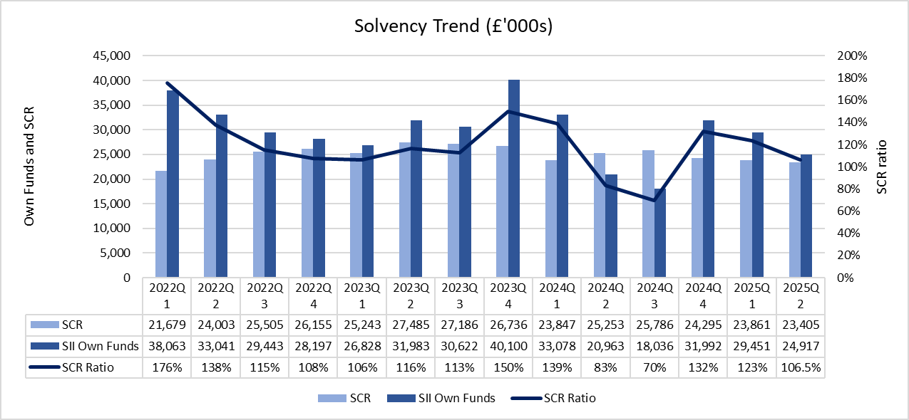

# Solvency II Technical Provisions Reconciliation

* 1. Reconciliation of Gross Solvency II Technical Provisions is shown in the table below:



* 1. Reconciliation of Reinsurance Solvency II Technical Provisions is shown in the table below:



# Quantitative reporting templates (QRTs)

The following templates are included:

|  |  |
| --- | --- |
| IR.02.01.02 | Balance sheet |
| IR.17.01.02 | Non-Life Technical Provisions |
| IR.23.01.01 | Own Funds |
| IR.28.01.01 | Minimum Capital Requirement only Life or only Non-Life Insurance or Reinsurance Activity |

**IR.02.01.02: Balance sheet**





**IR.17.01.01: Non-Life Technical Provisions**



**IR.23.01.01: Own funds**



**IR.28.01.01: Minimum Capital Requirement, Non-Life activity**

